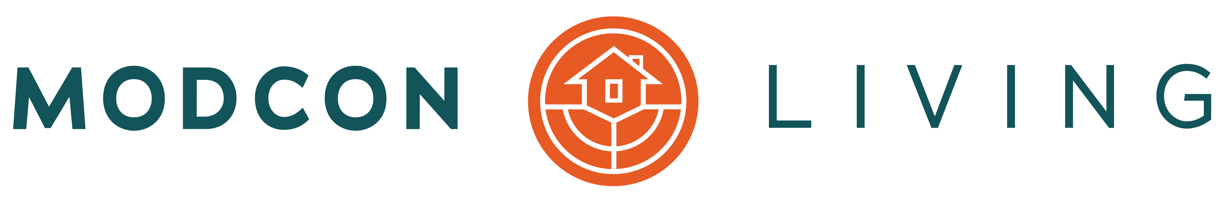

MODCON LIVING ANNOUNCES PLANS FOR RELOCATION
Nonprofit Invests in 5th Avenue Commercial Space for Expansion

Columbus, Ohio – (October, 24 2019) – Nonprofit Modcon Living has invested in 5th Avenue real estate in Columbus with plans for relocation and expansion by year end. The purchase, accomplished with the help of a community benefactor, provides a permanent home for the organization.

“With support from our community partners, we found the ideal street-facing property on 5th Avenue, and the timing is perfect,” said Julie Smith, executive director. “Sustaining communities and neighborhoods is a huge part of our mission, and as we plan for the future, investing in property ensures the future stability of the organization, and support for those we serve.”

Planned for soft opening in January 2020, and just one and half miles from Modcon Living’s current location, the recently updated space at 3840 East 5th Avenue in Columbus boasts countless benefits.

In addition to offering plentiful space for the popular Tool Library and staff offices, the location on the bus line will offer a private entrance with a welcome area, 1,200 square feet of community gathering space, an expanded workshop area, and ample kitchen to accommodate community events.

Free, paved, off-street parking at the new location offers more than double the existing parking space, with access to the new welcome center, as well as additional parking and storage for Modcon Living and Mod Squad vehicles and trailers.

Though the Tool Library will be temporarily closed effective November 9 to accommodate the organized move of more than 4,000 tools and supplies, Smith offers assurance on the uninterrupted operation of the Safe at Home and Mod Squad programs during the transition.

“Our mission, programs and staff remain the same, and other than the temporary closure of the Tool Library, it’s business as usual,” Smith continued. “Ultimately our new home will help us achieve our mission by making our programs better, and more accessible. It’s an exciting milestone for us.”

Plans for the opening of the new location adjacent to Modern Builders Supply, ODJFS Federal Credit Union and Skate Naked will be announced soon.

ABOUT MODCON LIVING
Originally established in 1991, Modcon Living is a nonprofit organization dedicated to sustaining homes and neighborhoods by providing reliable home repair and modification services, while providing vital home repairs for vulnerable senior and disabled homeowners. Its Safe at Home, Tool Library and Mod Squad programs have provided $5.5 million in home repair and related services since inception. Visit www.ModconLiving.org to learn more and connect via Facebook, Twitter and Instagram.

